## Fashion Retail Sales Analysis

### **Executive Summary**

This report provides a detailed analysis of the fashion retail dataset, focusing on key business questions regarding product performance, sales trends, and customer behavior. The analysis reveals a stable business with distinct seasonal sales patterns. A small cohort of high-value customers and a select group of core products are the primary drivers of revenue.

Key findings show no significant link between product price and customer satisfaction, but a subtle positive relationship between product ratings and customer loyalty. The data indicates that strategic decisions should be centered on optimizing inventory for top products, aligning marketing efforts with seasonal trends, and cultivating relationships with high-value customers.

### **Overall Performance Snapshot**

| Metric | Value |
| --- | --- |
| **Total Revenue** | $502,452.00 |
| **Total Transactions** | 3,400 |
| **Average Transaction Value (ATV)** | $147.78 |
| **Average Review Rating** | 3.0 out of 5 |

### **Product Revenue & Performance**

An analysis of product revenue shows a significant disparity between top-performing items and the rest of the catalog. The business relies heavily on a few key categories to drive the majority of its revenue.

* **Top Revenue Drivers:** **Handbags, Tunics, and Jeans** are the most lucrative products, combining for a substantial portion of total sales.
* **Underperforming Products:** Items like **Pajamas, Kimonos, and Caps** generate minimal revenue in comparison and may warrant a re-evaluation of their position in the inventory.

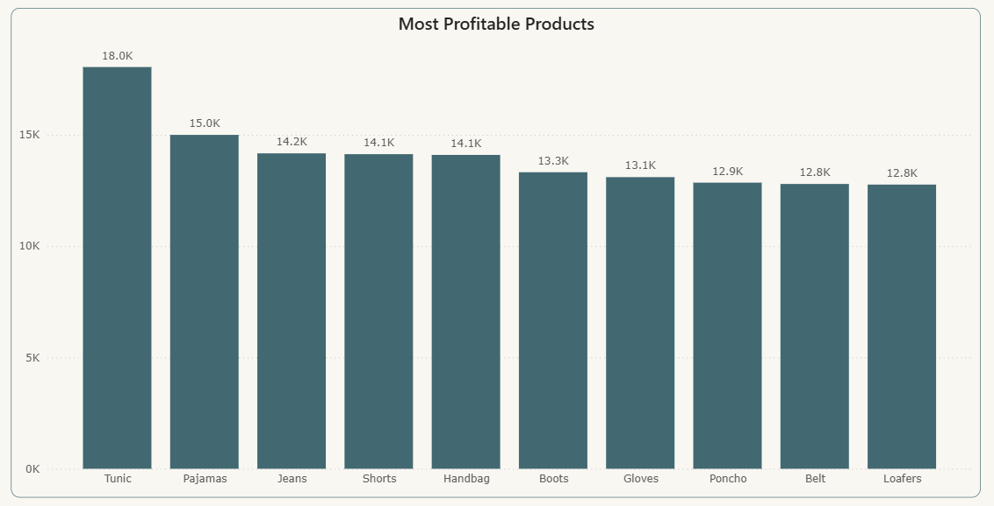

### **Customer & Payment Insights**

* **High-Value Customer Segment:** A small group of customers drives a significant share of revenue. The **top 10 customers alone contribute 7.89% of total sales**, highlighting the importance of this segment.
* **Payment Preferences:** Payment method usage is almost perfectly split between **Credit Card (50.5%)** and **Cash (49.5%)**. Importantly, the average purchase size does not differ significantly between these two methods, indicating that both are equally crucial to the business.

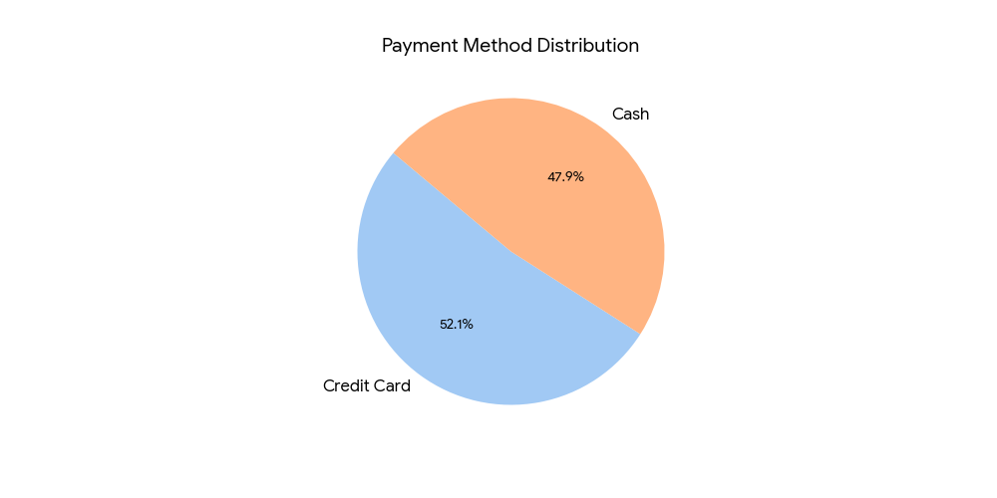

### **Monthly & Seasonal Sales Patterns**

The business experiences predictable and significant seasonal fluctuations in sales. Revenue consistently peaks in the spring months (**March and May**) and hits a low point in the late summer (**August**). This cyclical pattern is a critical factor for operational planning.

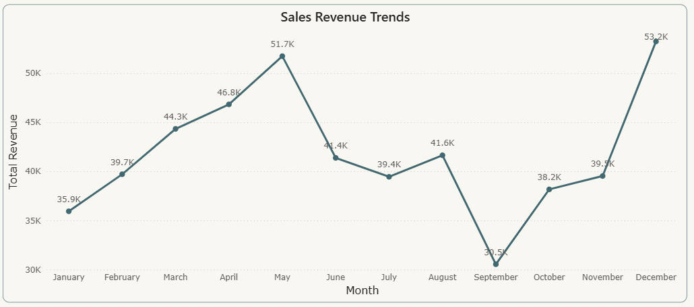

### **The Relationship Between Price, Ratings, and Satisfaction**

A key finding of this analysis is the clear disconnect between the price of a product and the satisfaction rating it receives from customers.

* **Price vs. Satisfaction:** There is **no statistical correlation (-0.0035)** between an item's price and its review rating. Customers do not perceive higher-priced items as being of inherently higher quality, or vice-versa. Satisfaction is driven by factors other than price.
* **Ratings and Loyalty:** Better product experiences appear to foster loyalty. Products purchased by **repeat customers have a slightly higher average rating** than those purchased by one-time buyers, suggesting quality is a factor in customer retention.

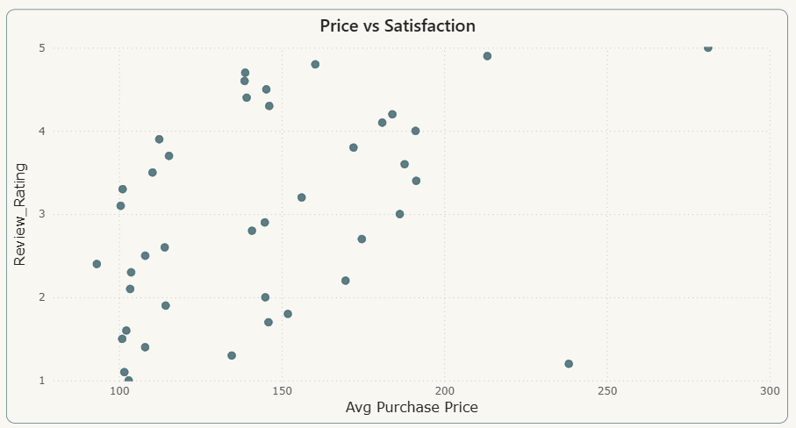

**Actionable Recommendations**

1. **Implement a Tiered Inventory Strategy**
   * **Action:** Classify products into performance tiers. Ensure top-tier items like **Handbags and Jeans** are always in stock. For underperforming items, consider promotional bundling or phased discontinuation.
   * **Impact:** Reduce holding costs for slow-moving stock and maximize revenue from proven sellers.
2. **Align Marketing with Seasonality**
   * **Action:** Plan marketing campaigns and product launches to coincide with the proven sales peaks in spring. During the August trough, run targeted promotions (e.g., "End of Summer Sale") to stimulate demand.
   * **Impact:** Maximize marketing ROI by reaching customers when they are most likely to buy and stabilize revenue during slow months.
3. **Develop a High-Value Customer Program**
   * **Action:** Create a loyalty or VIP program targeting the top 10% of spenders. Offer exclusive previews, personalized discounts, or early access to new collections.
   * **Impact:** Increase retention and lifetime value of the most profitable customer segment.
4. **Focus on Quality Across All Price Points**
   * **Action:** Since customer satisfaction is not tied to price, ensure rigorous quality control for all products, regardless of their cost. Use customer feedback from ratings to identify and address quality issues.
   * **Impact:** Enhance customer trust and encourage repeat purchases, which are linked to higher-rated products.